Tyler Butler

11/13/18

IT Analysis

Assignment 7

Answer question 4 - Develop a multilayer sequence diagram for the Book a Reservation use case that includes the domain classes and data access layers. This should be similar to the example shown in Figure 11-13.

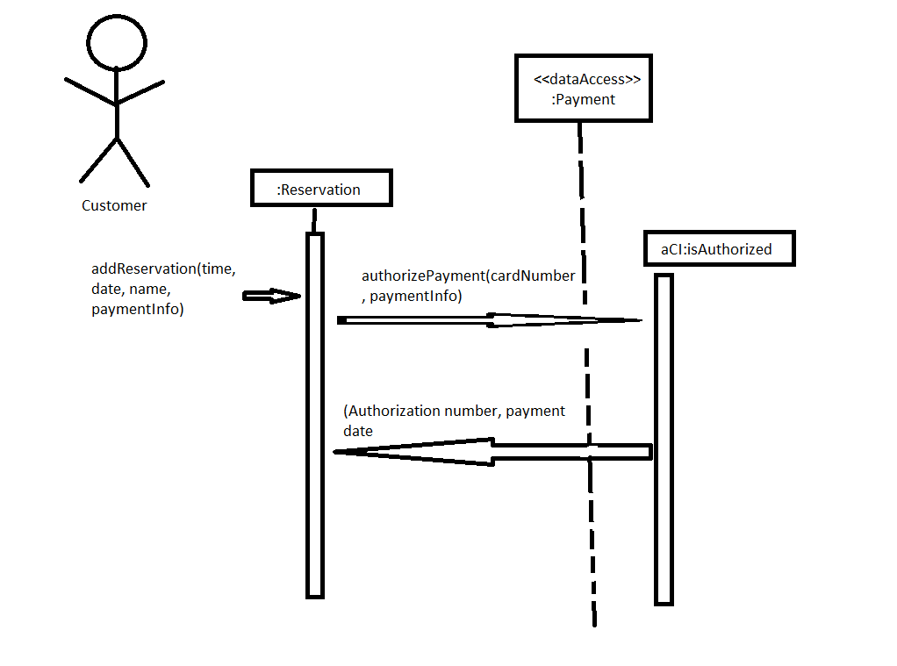

4. Answer question 7 - Develop a package diagram of the four subsystems (Resort relations, Student booking, Accounting and finance, and Social Networking) that includes all the problem domain classes. Use Figure 11-19 as an example of the diagram that is organized around the View, Domain, and Data Access layers.

